Volunteer Role Descriptor

Role | Education Officer
Reporting to | Drew Dalton (Chair of Trustees)
Average hours | 16 hours per month (not including additional volunteer team meetings)  Though please note that we are flexible around your life, work and childcare.

Volunteering at ReportOUT:
Reliable, well-trained and passionate volunteers are vital to the work of ReportOUT and to our three-year Strategic Plan (2019-2022). Our volunteers give more than their time and energy, they are a vital part of our organisation and so we invest heavily in volunteer support, training and development. We offer a professionalised volunteering experience at ReportOUT and our roles and your responsibilities given, will reflect this.

We seek highly skilled, flexible, reliable and experienced individuals to join us. Due to organisational demand we are after specific skills and abilities in our volunteering roles. Whilst all of our volunteer roles have clear roles as set out in this role descriptor, your role sometimes demands more and so we need people who are flexible and 'can do' in their approach.

Our volunteering process:

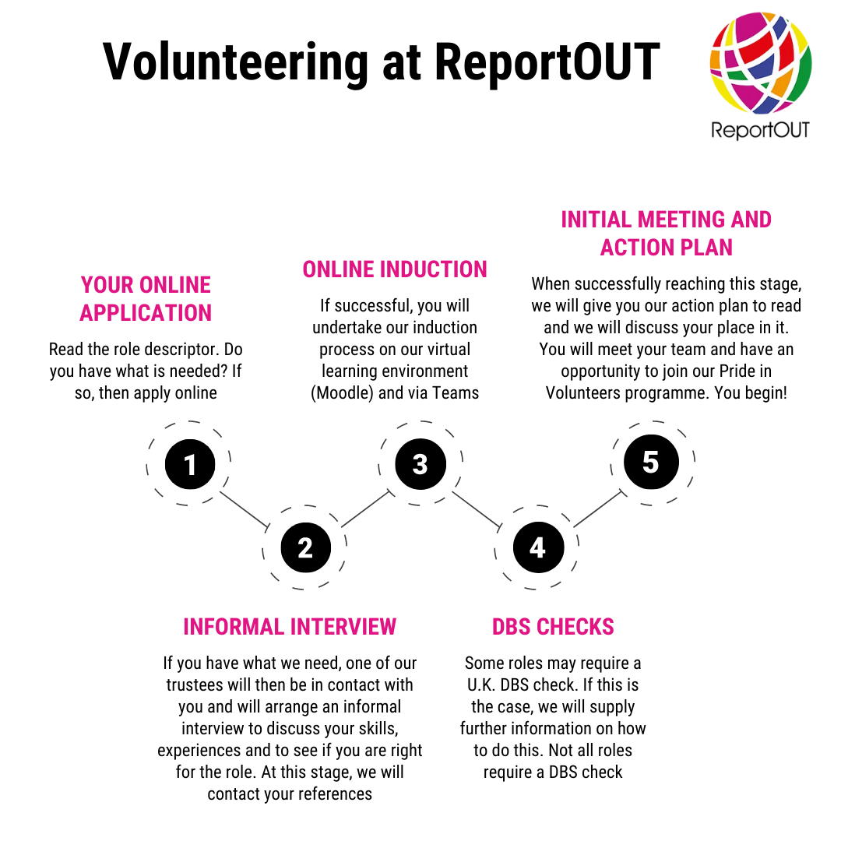

What does this role do?
The Education Officers plan, implement and operate our education projects that we as an education team, have planned for in our action plan. Their mission is to educate the public about global human rights abuses against sexual and gender minorities.

Previous projects have seen the team training up new volunteers or developing lesson plans and resources for schools. They have facilitated training courses for global gender and sexual minorities, implemented a podcast project collating global voices together and delivered training courses to charity professionals.

As you can see, this role is both varied and exciting and our Education Officers take part in curriculum design, run our Virtual Learning Environment (our ‘OUTAcademy’) and they decide a range of ways of engaging with the public to further awareness of human rights abuses faced by sexual and gender minorities globally. Finally, our Education Officers work with other teams to find opportunities for collaboration, they work confidently with the public and organisations and they measure the success of their projects through data collection.

What do we expect from you?
- a very pro-active ‘get up and go’ attitude to this role;
- a commitment to learning about the global human rights of sexual and gender minorities (training will be given about this);
- a willingness to learn curriculum and training course design and to use this learning pro-actively, both online and face-to-face;
- a willingness to offer training to volunteers and to the public as part of our education programmes and an ability to think outside of the box and be creative with our education projects;
- a willingness to reach out to global sexual and gender minorities when needed;
- a willingness to reach out to professionals in the United Kingdom;
- commitment to attend individual team meetings;
- commitment to attend our monthly volunteer team meetings;
- commitment to work with other volunteer teams where there is crossover in roles;
- to read and abide by relevant policies;
- to take part in a volunteer supervision with your lead trustee every 3 months;
- to use our internal and external communication systems when needed and to keep abreast of them often;
- strong IT skills so you can operate Microsoft systems and learn other systems with ease;
- to show excellent levels of punctuality and attendance at meetings and events;
- to be able to volunteer unsupervised, using your own initiative;
- to demonstrate excellent attention to detail;
- to be able to work effectively as part of a team;
- to be able to work effectively to conflicting deadlines;
- to show a strong commitment to equality and diversity principles, data protection laws and confidentiality guidelines;
- to help us to achieve our goals in our annual action plan;
- to be a positive advocate for ReportOUT publicly.

What skills, qualifications and experiences do you need for this role?
- experience in presenting to and/or training others - either formally or informally (a training or education background is highly desirable);
- a willingness to use Moodle - our online Virtual Learning Environment (VLE), or a strong ability to want to learn how to use online learning effectively;
- high quality curriculum design and lesson planning experience are both highly desirable skills (though training can be given);
- confidence in dealing with members of the public and professionals;
- excellent levels of written and spoken English are essential;
- an ability to use Zoom for training purposes, or a willingness to learn how to use it;
- an ability to speak any foreign languages is desirable but not essential.

