Volunteer Role Descriptor

Role | Human Rights Researcher
Reporting to | Jodie Weatherston (Trustee)
Average hours | 16 hours per month (not including additional volunteer team meetings)  Though please note that we are flexible around your life, work and childcare.

Volunteering at ReportOUT:
Reliable, well-trained and passionate volunteers are vital to the work of ReportOUT and to our three-year Strategic Plan (2019-2022). Our volunteers give more than their time and energy, they are a vital part of our organisation and so we invest heavily in volunteer support, training and development. We offer a professionalised volunteering experience at ReportOUT and our roles and your responsibilities given, will reflect this.

We seek highly skilled, flexible, reliable and experienced individuals to join us. Due to organisational demand we are after specific skills and abilities in our volunteering roles. Whilst all of our volunteer roles have clear roles as set out in this role descriptor, your role sometimes demands more and so we need people who are flexible and 'can do' in their approach.

Our volunteering process:

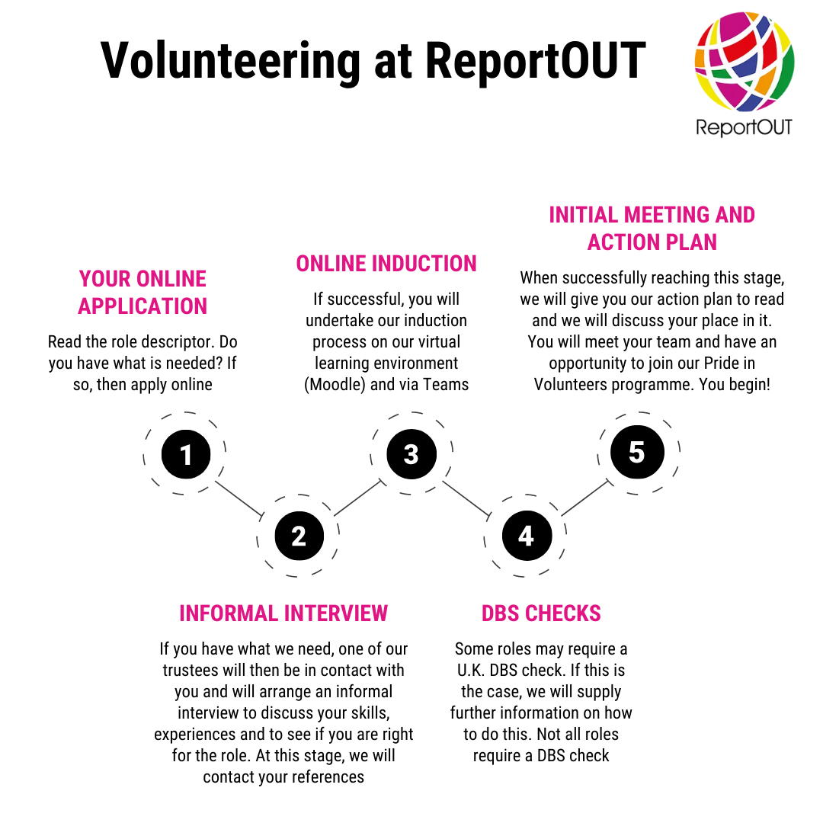

What does this role do?
The mission of the Human Rights Researchers is to conduct and collate research on global human rights abuses against sexual and gender minorities using a range of data collection techniques. This research is used to inform wider social, political and educational change.

Previous projects have seen the team completing country profiles on Pakistan and South Africa as well as completing profiles in partnership with an asylum seeker organisation on Brazil, Guinee and Namibia which have been used as supporting documents in court cases for people seeking asylum from these countries. Our Human Rights Researchers are just about to start large research projects working with partner organisations in Ethiopia and Morocco.

Researchers have also completed two different projects; one about corrective rape across the globe and the other on human rights abuses in Poland, which are currently being used by the campaigns team to set up campaign projects. We also launched our ‘OUT in Uganda’ research which documented the lived experiences of sexual and gender minorities living in one of the most homophobic countries in the world. This was featured by press including the Gay Times. Chapters from our ongoing ‘global book’ have been completed, which are documenting the current climate for sexual and gender minorities across the globe, including countries in Europe, Asia, Africa and North and Central America.

The focus of our future research projects in 2021-2022, include the following projects where we will need researchers for:
- our ‘Time to be Out’ profiles (literature reviews of countries which are used to support asylum seeker court cases);
- completing global book chapters (literature reviews of book chapters on each country across the globe for our upcoming book).

We are looking to recruit volunteers to help with the OUT in Egypt research, which requires one lead human rights researcher and three other human rights researchers. We are also looking for volunteers to help complete global book chapters and Time to be Out profiles.

What do we expect from you?
- a very pro-active attitude;
- a commitment to learning about the global human rights of sexual and gender minorities (training will be given about this);
- a willingness to reach out to global sexual and gender minorities when needed;
- a willingness to reach out to professionals in the United Kingdom;
- commitment to attend individual team meetings;
- commitment to attend our monthly volunteer team meetings;
- commitment to work with other volunteer teams where there is crossover in roles;
- to read and abide by relevant policies;
- to take part in a volunteer supervision with your lead trustee every 3 months;
- to use our internal and external communication systems when needed and to keep abreast of them often;
- strong IT skills so you can operate Microsoft systems and learn other systems with ease;
- to show excellent levels of punctuality and attendance at meetings and events;
- to be able to volunteer unsupervised, using your own initiative;
- to demonstrate excellent attention to detail;
- to be able to work effectively as part of a team;
- to be able to work effectively to conflicting deadlines;
- to show a strong commitment to equality and diversity principles, data protection laws and confidentiality guidelines;
- to help us to achieve our goals in our annual action plan;
- to be a positive advocate for ReportOUT publicly.

What skills, qualifications and experiences do you need for this role?
- experience in pulling together literature reviews from data sources;
- experience using qualitative and quantitative research methods;
- experience analysing qualitative and quantitative data;
- confidence in dealing with members of the public, activists and professionals;
- excellent levels of written and spoken English are essential;
- an ability to speak any foreign languages is desirable but not essential.

