Volunteer Role Descriptor

Role | Events and Fundraising Officer
Reporting to | Suzanne Butler (Treasurer)
Average hours | 16 hours per month (not including additional volunteer team meetings)  Though please note that we are flexible around your life, work and childcare.

Volunteering at ReportOUT:
Reliable, well-trained and passionate volunteers are vital to the work of ReportOUT and to our three-year Strategic Plan (2019-2022). Our volunteers give more than their time and energy, they are a vital part of our organisation and so we invest heavily in volunteer support, training and development. We offer a professionalised volunteering experience at ReportOUT and our roles and your responsibilities given, will reflect this.

We seek highly skilled, flexible, reliable and experienced individuals to join us. Due to organisational demand we are after specific skills and abilities in our volunteering roles. Whilst all of our volunteer roles have clear roles as set out in this role descriptor, your role sometimes demands more and so we need people who are flexible and 'can do' in their approach.

Our volunteering process:

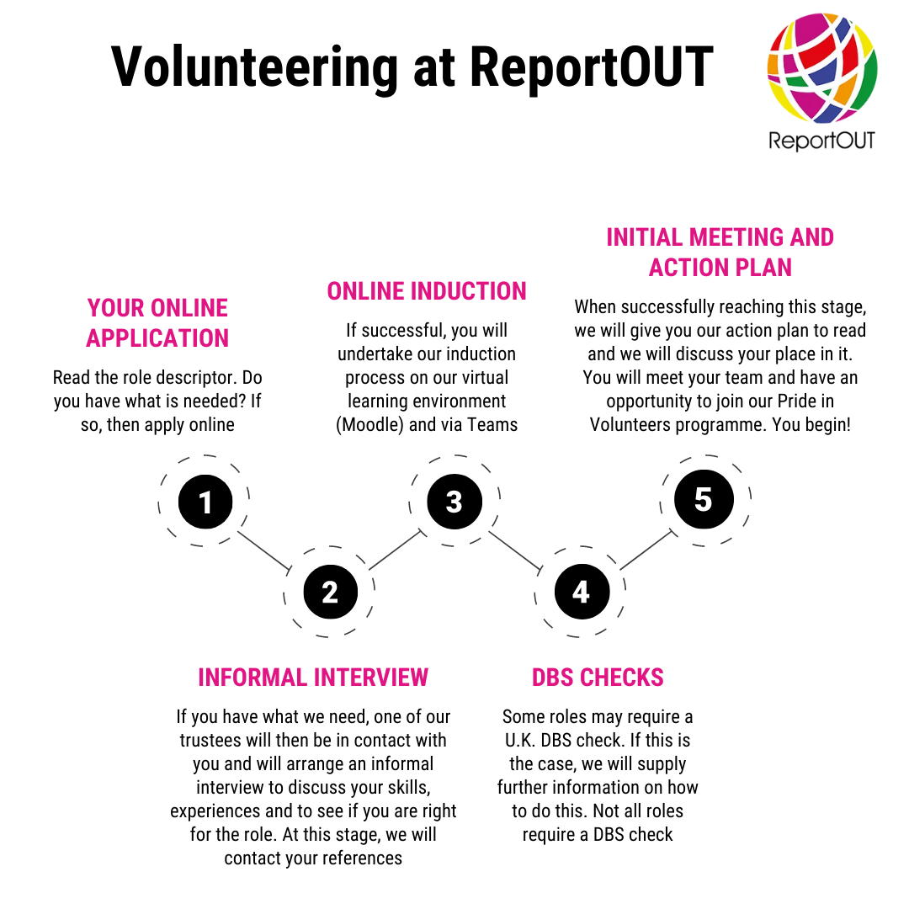

What does this role do?
The Events and Fundraising Officers plan, implement and operate our internal and external events that we as an events and fundraising team, have planned for in our action plan. Their mission is to host high quality and educational public facing events to raise public awareness about global human rights abuses against sexual and gender minorities. They also seek to raise the profile of ReportOUT to develop and strengthen networks with other organisations, and to raise funds to ensure the financial sustainability of ReportOUT.

Previous events have been organised around important dates in the SOGIESC calendar such as Human Rights Day and LGBT History Month. Panel events and talks have been held online which have been well attended, successful and well received.

As you can see, this role is both varied and exciting and our Events and Fundraising Officers collaborate to develop an events’ plan and strategy for the coming year, where they design and develop innovative and inspirational events and set ambitious but achievable fundraising targets and they have the autonomy to be creative in their role. They are supported and work closely by the other teams within ReportOUT such as the Social Media team, to help market events and drive attendance.

What do we expect from you?
- a very pro-active ‘get up and go’ attitude to this role;
- a commitment to learning about the global human rights of sexual and gender minorities (training will be given about this);
- a willingness to create innovative and inspirational public events and develop relationships with guest speakers and panels;
- a willingness to reach out to global sexual and gender minorities when needed;
- a willingness to reach out to professionals in the United Kingdom;
- commitment to attend individual team meetings;
- commitment to attend our monthly volunteer team meetings;
- commitment to work with other volunteer teams where there is crossover in roles;
- to read and abide by relevant policies;
- to take part in a volunteer supervision with your lead trustee every 3 months;
- to use our internal and external communication systems when needed and to keep abreast of them often;
- strong IT skills so you can operate Microsoft systems and learn other systems with ease;
- to show excellent levels of punctuality and attendance at meetings and events;
- to be able to volunteer unsupervised, using your own initiative;
- to demonstrate excellent attention to detail;
- to be able to work effectively as part of a team;
- to be able to work effectively to conflicting deadlines;
- to show a strong commitment to equality and diversity principles, data protection laws and confidentiality guidelines;
- to help us to achieve our goals in our annual action plan;
- to be a positive advocate for ReportOUT publicly.

What skills, qualifications and experiences do you need for this role?
- experience in presenting and hosting events is highly desirable;
- a willingness plan ambitious and achievable fundraising targets and find creative ways to achieve them;
- experience in planning internal and external events are both highly desirable;
- confidence in dealing with members of the public and professionals;
- excellent levels of written and spoken English are essential;
- an ability to use Zoom for events purposes, or a willingness to learn how to use it;
- an ability to speak any foreign languages is desirable but not essential.

